Leadership Detroit Class 44
Health & Wellness
December 14, 2023
Sponsored by:
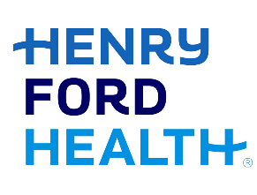

Thursday, December 14 Pistons Performance Center, 6201 2nd Ave, Detroit, MI 48202

8:30 a.m. Class Arrival & Breakfast

9:00 a.m. Overview & Expectations
Devon O’Reilly, Senior Director, Community Engagement and Leadership Development

9:15 a.m. Future of Health and Destination Grand
Robin Damschroder, Chief Financial & Business Development Officer, Henry Ford Health

10:00 a.m. Tour of Pistons Performance Center

10:45 a.m. Diversity, Equity, Inclusion, and Social Justice (DEIJ) in Health Care
Dr. Kimberlydawn Wisdom, Sr. Vice President of Community Health & Equity, Chief Wellness and Diversity Officer

11: 15 a.m. Equity in Healthcare
Dr. Martina Caldwell, Medical Director, Henry Ford Health

Courtney Latimer, MSA, Manager, Community Health Programs and Strategies, Henry Ford Health

Valencia Stoudamire, Vice President, Supplier Diversity, Henry Ford Health

12:00 p.m. Lunch Plum Market Catering

1:15 p.m. Group Stretch lead by Dana Armenteros

1:30 p.m. Fostering Connection, Wellness, & Hope for the Future
Mark Ostach, Speaker & Author

3:15 p.m. Healthcare Technology
Javier Evelyn, Founder, Alerje

Dr. Phillip Olla, Executive Director, Center for Augmenting Intelligence, University of Detroit Mercy

Hass Saad M.D., Founder, Better Box Self-Care

4:15 p.m. Wrap Up & Class Announcements

4:30 p.m. Social Hour @ Northern Lights Lounge

Note- We will be collecting toys for the Pistons holiday drive at Eastern Market

